**The Simple Harmonic Oscillator**

Oscillations are present in all forms of nature in things such as vibrating molecules, electromagnetic waves as well as the sway of the tree and branches. A quantum oscillator is an analog form of the classic harmonic. This is because at the vicinity of an equilibrium a random smooth potential is estimated as a harmonic potential. A harmonic oscillator comprises a particle with potential energy and it’s given by the formula:

V(x)=½kx² where k = constant

In this quantum harmonic oscillator, a diatomic molecule that pulsates in what resemble two weights on a spring. The potential energy is directly proportional to the displacement from the balancing point. The quantum harmonic oscillator has the following energy levels as shown below in the figure. En =µn +1/2, µ= hf f= frequency h = planks constant

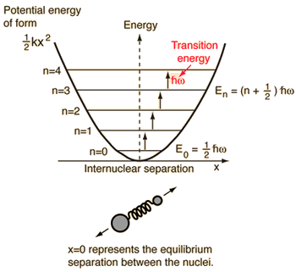

A simple harmonic oscillator cannot have zero energy as outlined in the harmonic oscillator potential. The energy present at the ground level is called the zero ground of vibration. The energy does not go to zero but it is down to the most minimum level making the graph look as if it is flat.

The description of energy in the uncertainty position can be shows by the formula below 

ψn(x)=Nne−β2x2/2Hn(βx),n= 0, 1 , 2

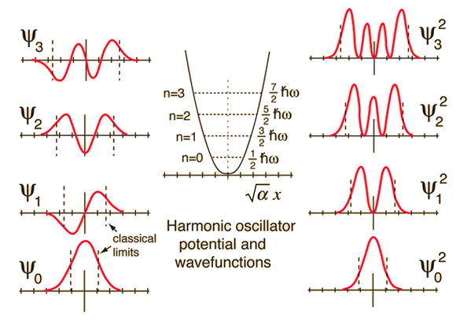

**Hydrogen atom**

An atom of hydrogen exists in the chemical element of hydrogen. The atom consists of a proton which is an electron containing positive charges and a neutron which on the other hand contain an electron whose charge is negative and is attracted towards the proton as in figure c. The proton and the neutron are bound to the nucleus by a special attraction of the electrostatic about the positive and negative electrons Spherical harmonic the system used in defining the wave function of the electrons which are present in the hydrogen atom. 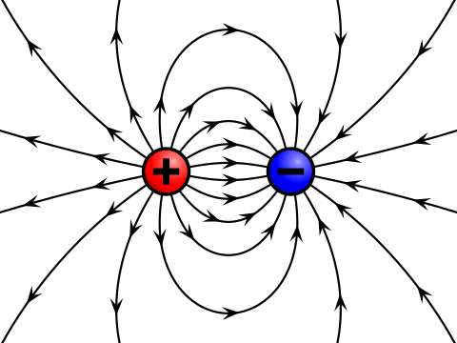

Figure c showing the attraction of the electron to the proton

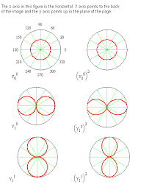The spherical harmonics are used mainly because it is easy to use their coordinates and in turn, the wave function can be separated to each coordinate’s functions. The figure below shows the representation of if wave functions in spherical harmonics

figured

The above figured, shows the spherical harmonics

The energy level in the proton shows where the nucleus is likely to appear it is spherical. The spherical harmonics also have orbitals; this is a mathematical function that shows the position and the behaviour of an electron which resembles that of a wave in an atom. The orbital is represented by 1s because it has no direction to go to.

One has to determine where wave function exist on all the energy levels and if you have not determined which level, it is in. therefore you to check the existence of the electron in each level so that you can do away with the other levels. So, if you have not examined the electron is in all the levels and also in none. Some wavefunctions happen to look alike and produced energies. The directions of the spherical harmonics vary and the place where the energy levels of the angular direction points are where you are likely to found the electron. Where there is no level the electron will not be found hence there is no need to look for it in such

**Work cited**

Webb, Simon P., and Sharon Hammes-Schiffer. "Fourier grid Hamiltonian multiconfigurational self-consistent-field: A method to calculate multidimensional hydrogen vibrational wavefunctions." *The Journal of Chemical Physics* 113.13 (2000): 5214-5227.

https://en.wikiversity.org/wiki/Quantum_mechanics/Harmonic_oscillator